Creating Jenkins Pipeline Script for Java application

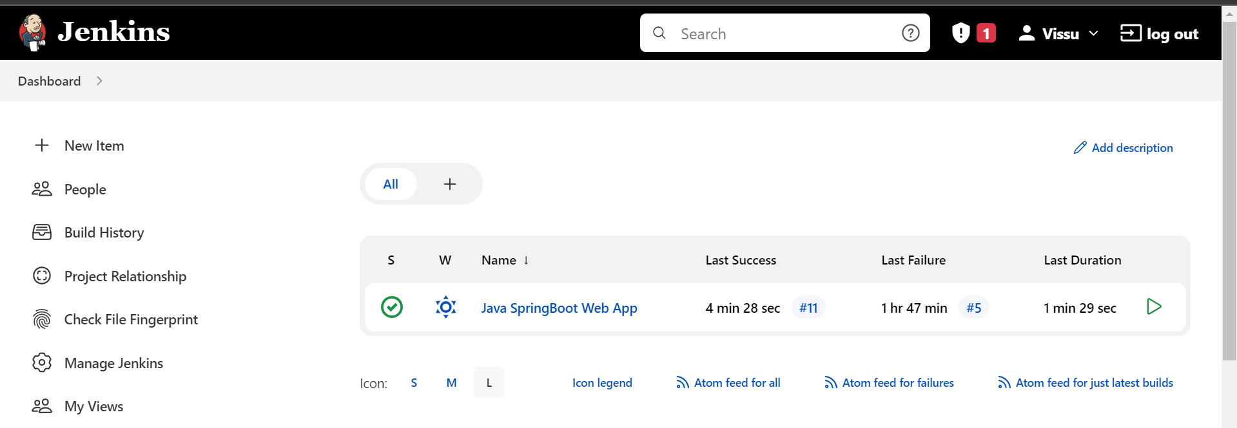

Click on “New Job”

Enter “Job Name”

Select “Job Type = Pipeline”

Click on “OK”

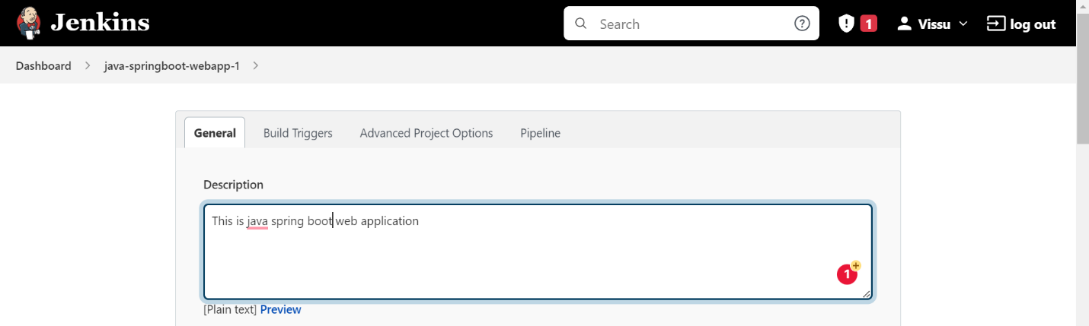

Enter Description of the Job

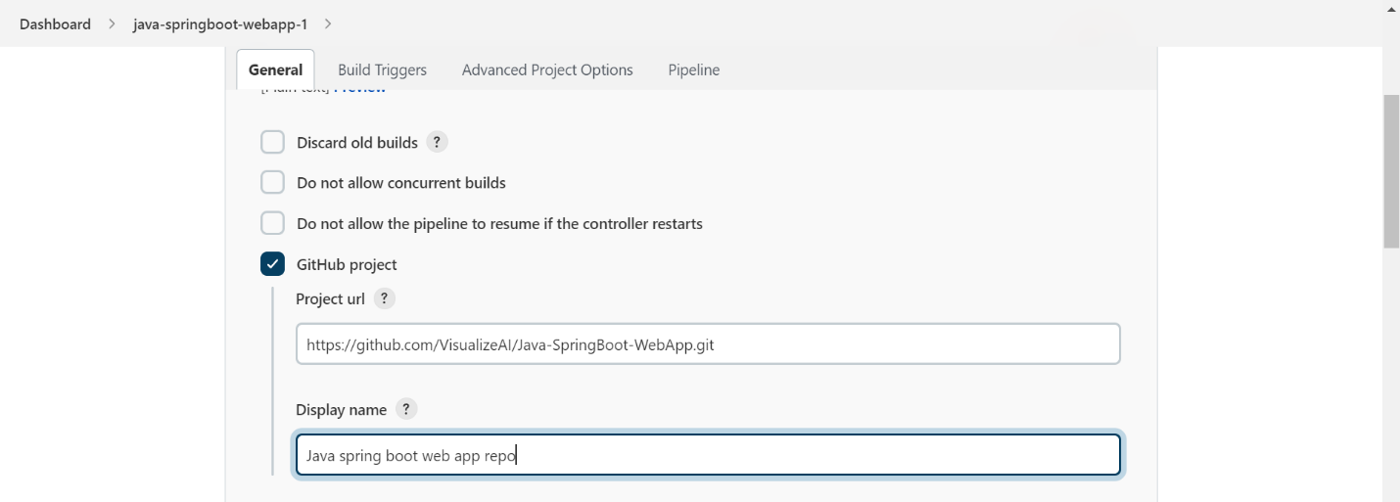

Select GitHub Project

Enter project Url and Display name

Select the “Build Trigger = GitHub hook trigger for GITScm polling”

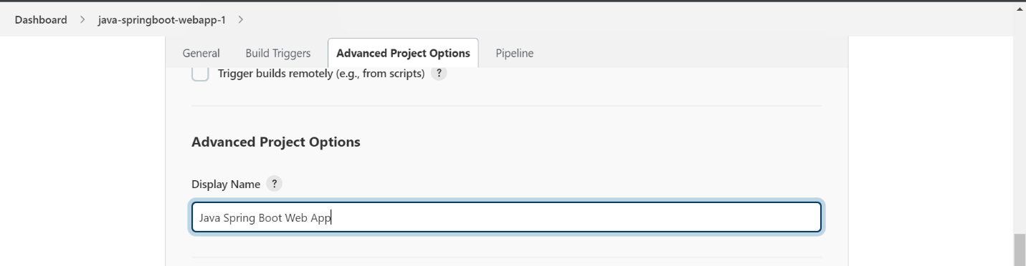

Enter a Display name for the project

Select “Pipeline = Pipeline script”

1. Running the Job in Specific Slave Node

The highlighted code will specify that, run this job only the slave node which are having the variable label value as “java”.

2. Adding the stages to the pipeline

The highlighted code specifies adding stages in the pipeline.

Stages is like an array having n number of stage blocks.

A Stage is a combination of steps. Each stage will have a name for it.

How to add cloning git repository step in the steps block on stage “code checkout” block?

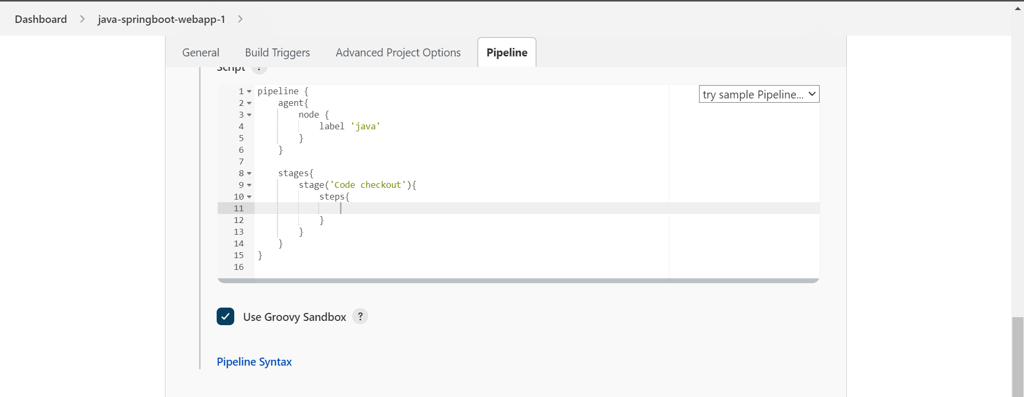

Click on “Pipeline Syntax”.

This will open a new tab to generate the declarative pipeline for the given steps.

Select the “git” in sample step dropdown.

Enter the Repository URL

Enter the Branch Name

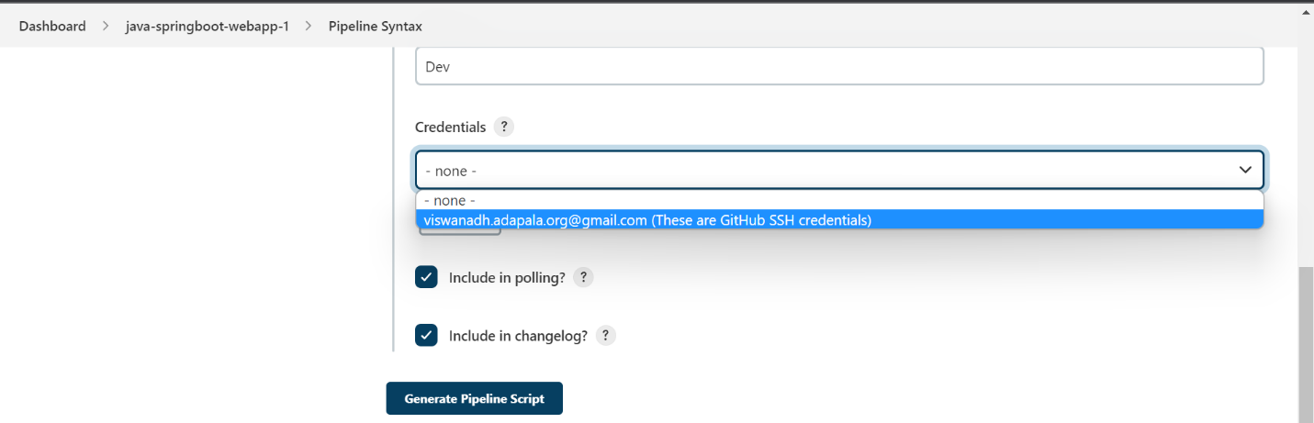

Select the credentials for the GitHub account.

Credentials are required for Private repos, and optional for public repos.

Click on “Generate Pipeline Script”

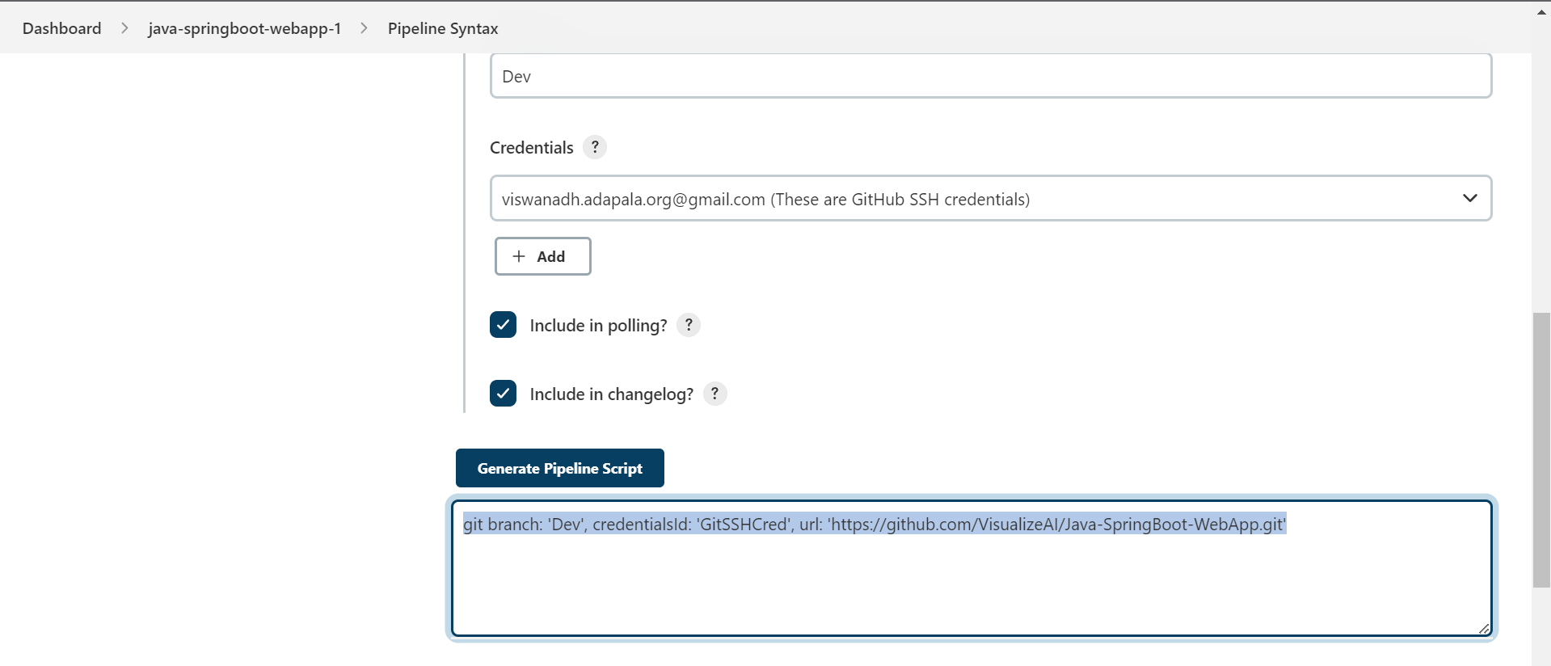

Copy the highlighted line and paste it in the steps block for the stage “Code checkout”.

Now, click on “Apply” and “Save”.

Check this job by click on “Build Now”

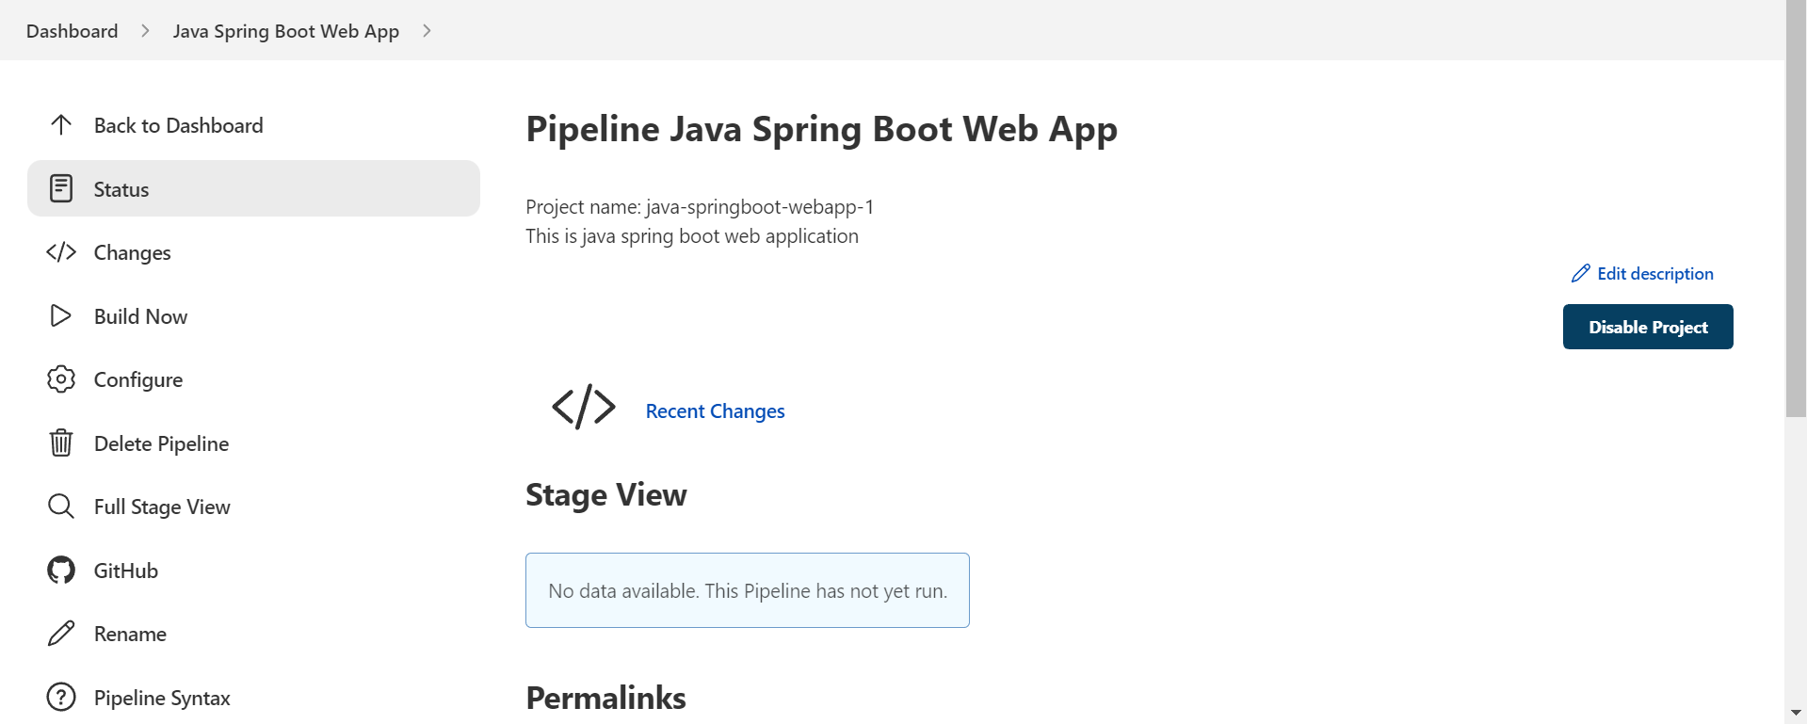

We can see our 1st build is started and executed the successfully with one stage called “Code Checkout” which we defined in our pipeline.

Now, check the build logs by clicking on the build number “1”.

Click on “Console output”

We can see that it is using the GitHub credentials we specified to clone the repo.

It is also saying which jenkins user started/initiated this job. “Vissu”.

It is also saying on which slave node this job is running and workspace path of the job in slave node machine.

Adding Build stage with Maven